ASSIGNMENT 1

AUTOMATIC NIGHT LAMP BEGINNER

**Components**:

* 1 x Mini Breadboard
* 1 x Arduino UNO R3
* 1 x LDR Photoresistor Sensor
* 2 x 1 kΩ resistors
* 1 x Red LED

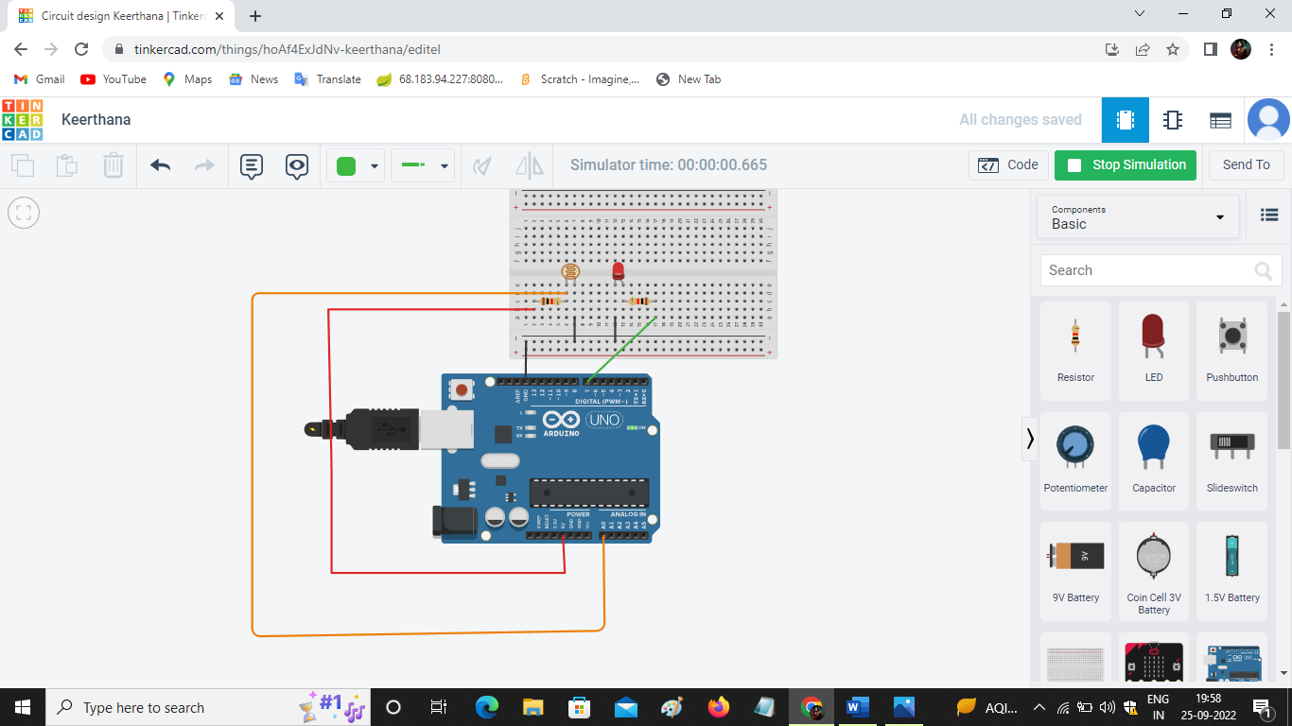**Circuit Diagram:**

This circuit will be used for automatic night Lamp Turn ON/Turn OFF. When there is no sunlight then lamp (LED) glows and When there is sunlight then lamp (LED) does not glow.

**Program:**

void setup()

{

Serial.begin(9600);

pinMode(7,OUTPUT) ;

}

void loop()

{

int c = analogRead(A0) ;

Serial.println(c) ;

if(c<500)

{

digitalWrite(7,LOW) ;

}

else

{

digitalWrite(7,HIGH) ;

}

}